Find a tyvec envelope (ala fed ex) with three stars. It contains a leather wallet that is marked with chevrons. In the wallet, there is a metal card with what appear to be complex mathematical formulas.. But they contain symbols that make no sense.

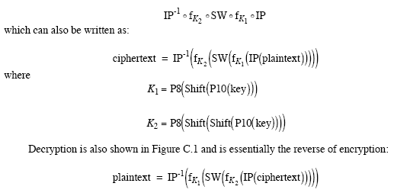

Also inside is the following handwritten note. On a card with a rothko painting on it.

Art , I hope that you get to this note. I've used all precautions to keep you safe from harm but have been compromised and urge you to take all measures of caution.

It is possible that I will be captured before I see you again and I am preparing to take the drastic measures to protect you and our mission.

If I survive, I want to be done with this business. We’ve fulfilled our duty and have earned a peaceful future. I’ve made you a simple cipher ring so we can talk privately — outside of the official channels.

Please be careful

Love,
Edith

